

“Gummy Soul producer Amerigo Gazaway makes his ingredients sound as if they were born to be together”
-NPR

“Brilliant”
-Questlove

“Wide ranging stylistic format that never feels overcooked”
-Soul Train

“Two great flavors that tastes great together”
-OkayPlayer

“One of the more intriguing mashup albums of 2011”
-MTV Hive

Fe l a S o u l :

Press Highlights:

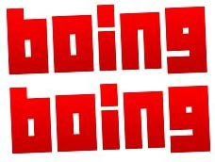

9/13/2011

“Amerigo seamlessly intertwines the two into something new and original”

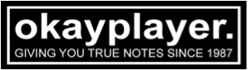

“The marriage of De La Soul‘s “Breakadawn” and Fela Kuti‘s “Water No Get
Enemy”…might have more helium in it than the balloon mindstate original”



9/16/2011

“Just in time…dope mashup by Gummy Soul”



9/19/11

“…One of the most intriguing mashup albums of 2011”



12/21/11

“Gummy Soul producer Amerigo Gazaway makes his ingredients sound as if they were born to be together.”
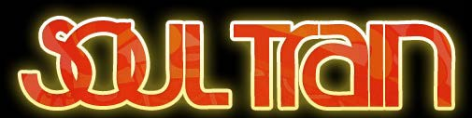

“…wide ranging stylistic format that never seems overcooked”

Honors:



12/16/11

“Top Hip-Hop releases of 2011—Nashville”



12/21/11

“Top 5 Bandcamp Albums of 2011”



12/22/11

“Top 10 African albums of 2011”

12/23/11

“Best Albums of 2011”

12/27/11

“Top 5 independent Soul Artist of 2011”



12/29/11

“Top Mixtapes of 2011”

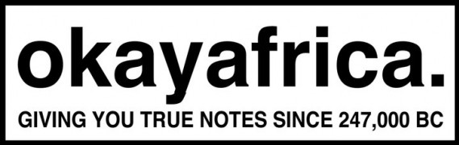

12/29/11

“Top LP’s of 2011”

Bizarre Tribe; A Quest To The Pharcyde:
Press Highlights:



9/14/12

“…Mash-up mix by Gummy Soul that merges 1990s New York City with 1990s Los
Angeles”



9/13/12

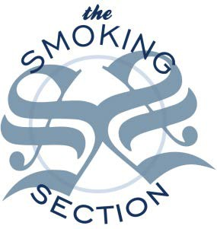

9/14/12

9/13/12

“Mosher-upper Amerigo Gazaway does his cotdman thing and the results are funky like your great-grandpas draws with a fish in it.”

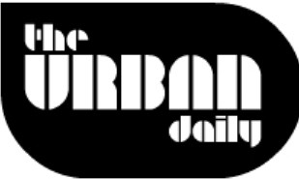

9/14/12

“…the mad scientists behind the Fela Soul mash-up, blow our collective minds with this ingenious mash-up of The Pharcyde and A Tribe called quest called Bizarre Tribe A Quest to The Pharcyde.”



9/14/12

“Rather than just using the OG instrumentals, Gazaway flips the original samples and reinterprets them.”

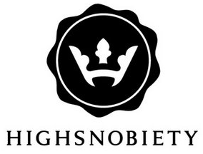

9/14/12

“5 Best New Music Videos of The Week”


9/13/12

“Gummy Soul and Amerigo Gazaway combine the best of two legendary factions…”



8/13/12

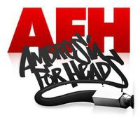

9/13/12 “Dope”



9/13/12

“Classy conjoinment conducted by Amerigo Gazaway of Gummy Soul”


9/13/12
“Handled by Amerigo Gazaway, of Gummy Soul, who famously made that Fela Kuti and De La Soul project, Fela Soul, last year. Yeah, if you heard that project, than you already know what it is.”



9/14/12

“At times, I forget that I’m listening to a 3rd party album. Something this synthetic shouldn’t sound so organic. But it does. It’s a testament to the connectivity of the artists, but speaks volumes of just how good Amerigo Gazaway really is.”



9/25/12 “HEATER OF THE DAY”

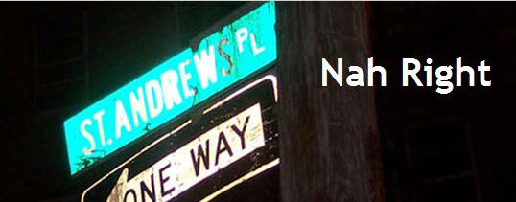

“Very well done.”

9/25/12



9/25/12

9/25/12 “Absolute Fire!”

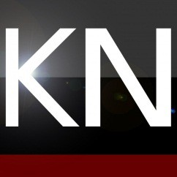

9/26/12

“Not only does Gazaway bring ATCQ and The Pharctde together perfectly on te whole project but, for ‘Pharcyde of The Moon’ he brings Black Moon into the
mix.”

“I Can’t Get Off Of The Facebook” –Amerigo Gazaway (Single): Press Highlights:

5/18/12

“MTV (Hive) favorites Gummy Soul dropped an R&B & hip—hop fused ode to Master
Zuckerberg’s addictive platform with this joyous tune”

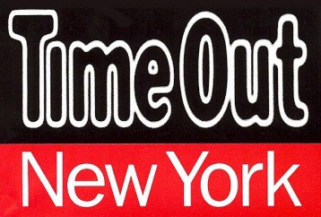

5/18/12

“…jangly, jolly guitar riff and a chorus that you won't be able to wipe from your mind for days.”

“Who We Are” –Amerigo Gazaway (Single): Press Highlights:
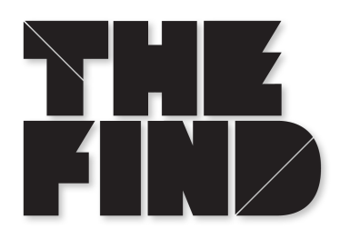

11/26/11

“A track that articulates the individual spirit of freedom and the people’s desire for socioeconomic revolution”

11/21/11

“…Worth repeat listens”

“Rosebud”- Amerigo Gazaway (Travon Martin tribute) Press Highlights:

4/13/12

“The pairing of the indie-folk songstress' haunting vocals from "For You" with Gazaway's stark, straightforward storytelling makes for a shiver-worthy listen.”

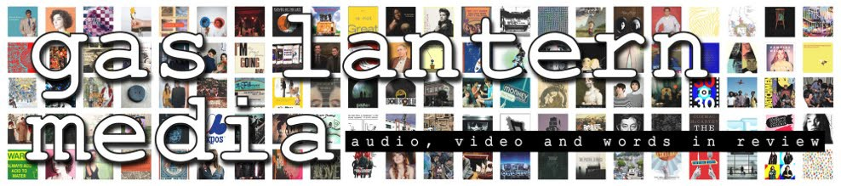

4/13/12

“Gazaway's incorporation of Sharon Van Etten, and his powerful reference, comparing Martin's young death to the life he could have lived through Orson Welles' "Citizen Kane" is impeccable.”



4/13/12

“Good music should be shared”

